Online Blood BAnk
Objective:
Online Blood Bank is an online application that brings dignity to Life of people by making Quality blood and blood samples available when needed.
Users of the System:
- Admin
- User
Functional Requirements:
- Build an application that User can access and get blood donar details.
- The application should have signup, login, profile, and blood bank page.
- This application should have a provision to maintain a database for user information, blood information.
- Also, an integrated platform required for admin and customer.
- Administration module to include user management and blood bank Management.

While the above ones are the basic functional features expected, the below ones can be nice to have add-on features:
- Filters for donar like near by location.
- Multi-factor authentication for the sign-in process

Output/ Post Condition:
- Records Persisted in Success & Failure Collections
- Standalone application / Deployed in an app Container

Non-Functional Requirements:

Security | - App Platform –UserName/Password-Based Credentials  - Sensitive data has to be categorized and stored in a secure manner  - Secure connection for transmission of any data
Performance | - Peak Load Performance  - Online Blood Bank -< 3 Sec  - Admin application < 2 Sec  - Non Peak Load Performance  - Online Blood Bank < 2 Sec  - Admin Application < 2 Sec
Availability | - 99.99 % Availability
Standard Features | - Scalability  - Maintainability  - Usability  - Availability  - Failover
Logging & Auditing | - The system should support logging(app/web/DB) & auditing at all levels
Monitoring | - Should be able to monitor via as-is enterprise monitoring tools
Cloud | - The Solution should be made Cloud-ready and should have a minimum impact when moving away to Cloud infrastructure
Browser Compatible | - IE 7+  - Mozilla Firefox Latest – 15  - Google Chrome Latest – 20  - Mobile Ready

Technology Stack
Front End | Angular 7+  Google Material Design  Bootstrap / Bulma
Server Side | Spring Boot  Spring Web (Rest Controller)  Spring Security  Spring AOP  Spring Hibernate
Core Platform | OpenJDK 11
Database | MySQL or H2

Platform Pre-requisites (Do’s and Don’ts):
- The angular app should run in port 8081. Do not run the angular app in the port: 4200.
- Spring boot app should run in port 8080.

Key points to remember:
- The id (for frontend) and attributes(backend) mentioned in the SRS should not be modified at any cost. Failing to do may fail test cases.
- Remember to check the screenshots provided with the SRS. Strictly adhere to id mapping and attribute mapping. Failing to do may fail test cases.
- Strictly adhere to the proper project scaffolding (Folder structure), coding conventions, method definitions and return types.
- Adhere strictly to the endpoints given below.

Application assumptions:
- The login page should be the first page rendered when the application loads.
- Manual routing should be restricted by using AuthGaurd by implementing the canActivate interface. For example, if the user enters as http://localhost:4200/signup or http://localhost:4200/home the page should not navigate to the corresponding page instead it should redirect to the login page.
- Unless logged into the system, the user cannot navigate to any other pages.
- Logging out must again redirect to the login page.
- To navigate to the admin side, you can store a user type as admin in the database with a username and password as admin.
- Use admin/admin as the username and password to navigate to the admin dashboard.

Validations:
- Basic email validation should be performed.
- Basic mobile validation should be performed.
Project Tasks:
API Endpoints:
USER
Action | URL | Method | Response
Login | /login | POST | true/false
Signup | /signup | POST | true/false
Get All Sample | /sample | GET | Array of samples
Get All Donor | /donor | GET | Array of Donors
Get All donor by group | /donor/{group} | GET | List of Donor Details by blood group
Get All Sample by group | /sample/{group} | GET | List of sample Details by blood group
Get Donor | /donor/{id} | GET | Particular Donor
Get Sample Details | /sample/{id} | GET | Particular Sample
ADMIN
Action | URL | Method | Response
Get All donor | /donor | GET | Array of donor
Get All sample | /sample | GET | Array of sample
Add Sample | /admin/addSample | POST | Sample added
Delete Sample | /admin/sample/{id} | DELETE | Sample deleted
Update Sample | /admin/sample/{id} | PUT | Sample Updated
Update Donor | /admin/donor/{id} | PUT | Donor Updated
Delete Donor | /admin/donor/{id} | DELETE | Donor Removed

Frontend:
User:
Login:
Output Screenshot:
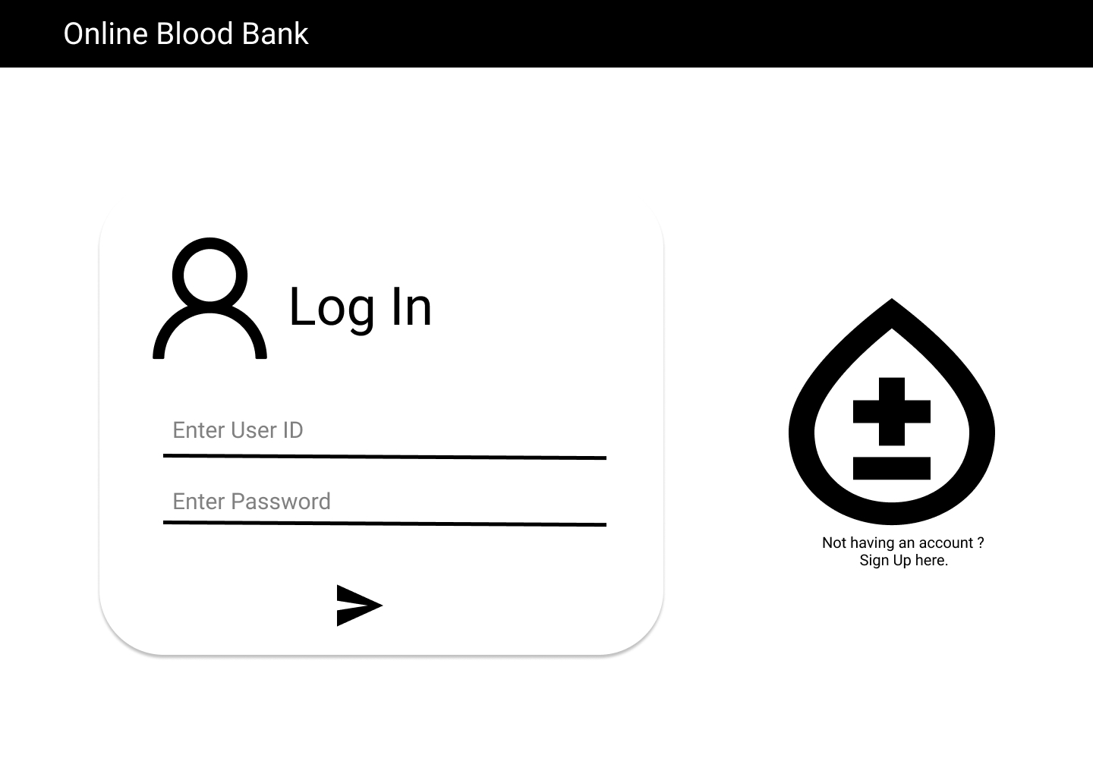
Signup:
Output Screenshot:
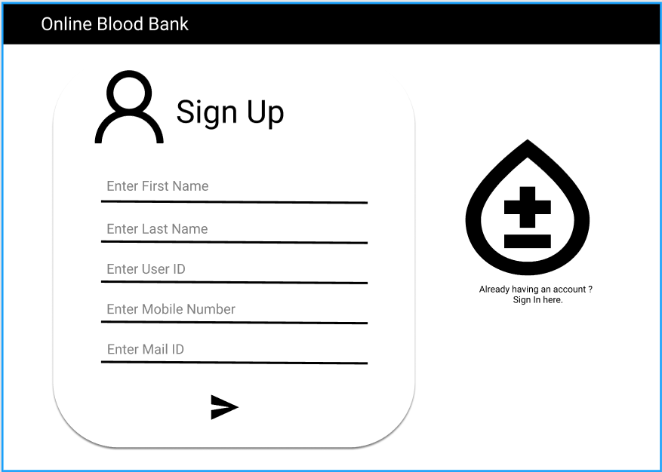

Blood Sample:
Output Screenshot:
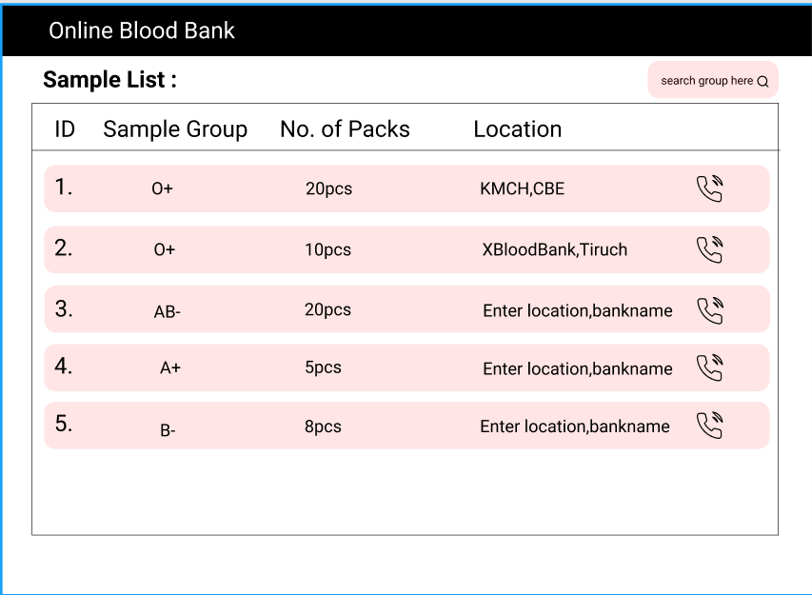

Blood Sample ID:
Output Screenshot:
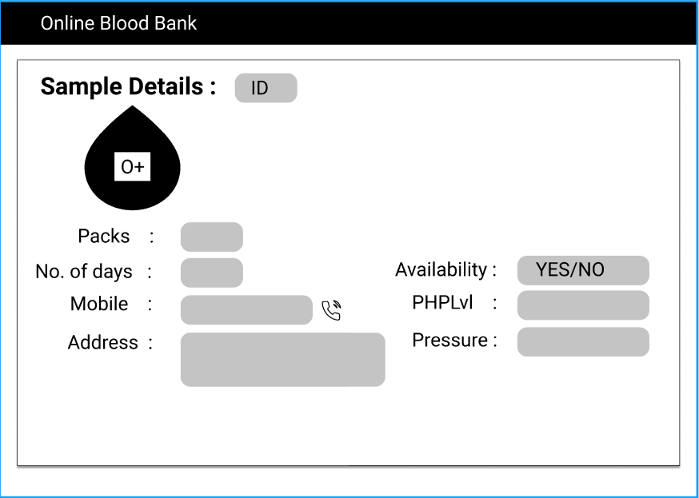
Donors:
Output Screenshot:
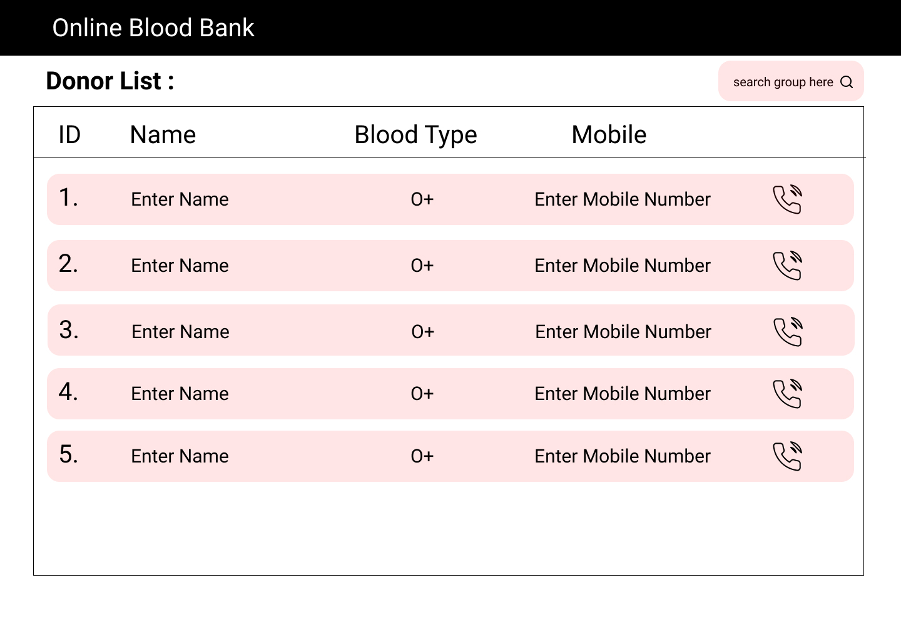
Donor By Id:
Output Screenshot:
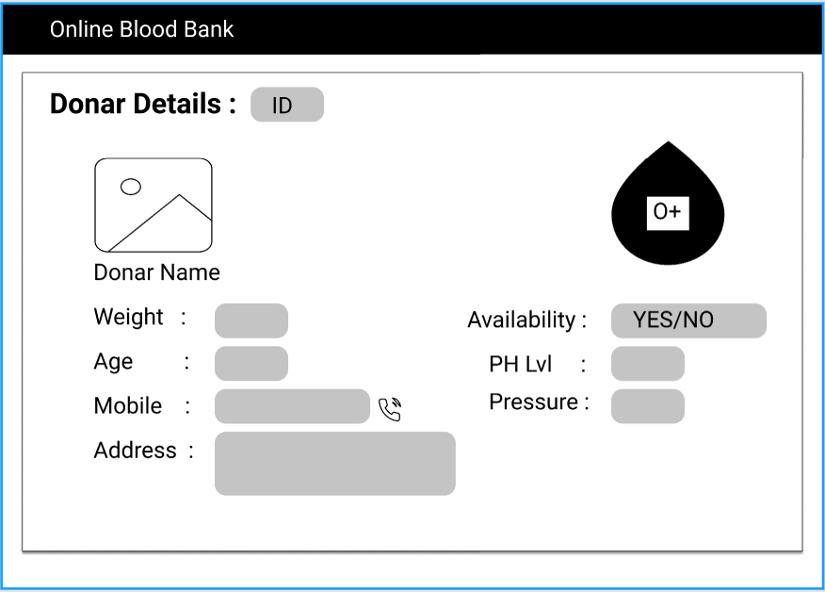
Admin:
All Sample:
Output Screenshot:
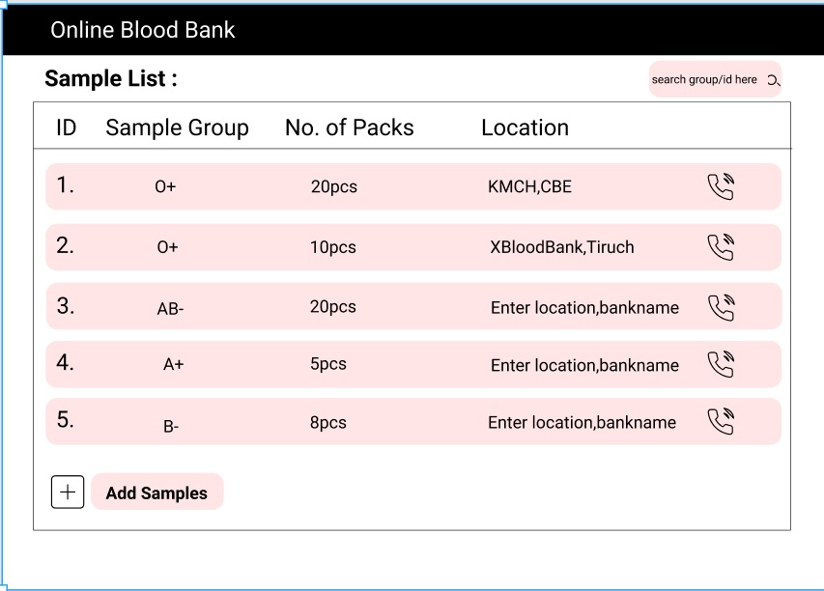

Add Sample:
Output Screenshot:
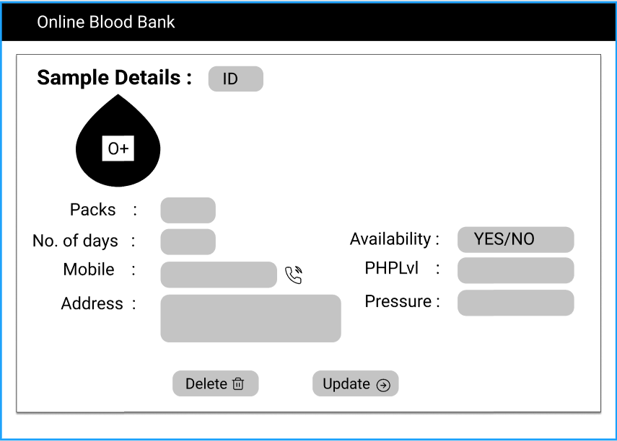
All Donors:
Output Screenshot:
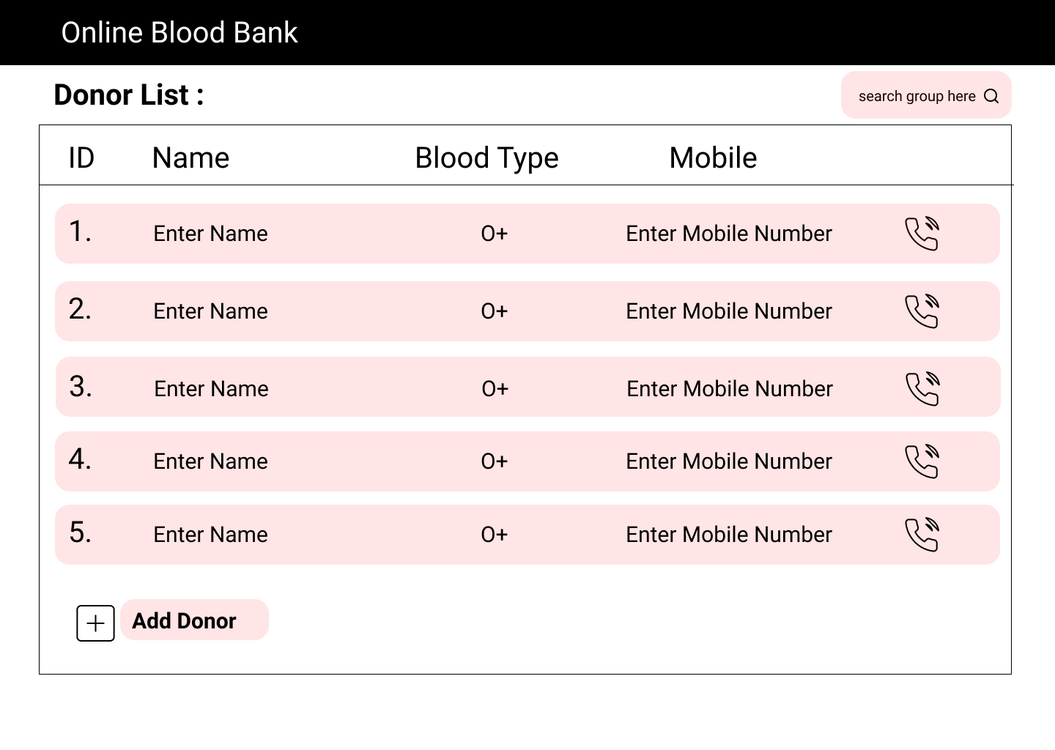
Update Donor:
Output Screenshot:
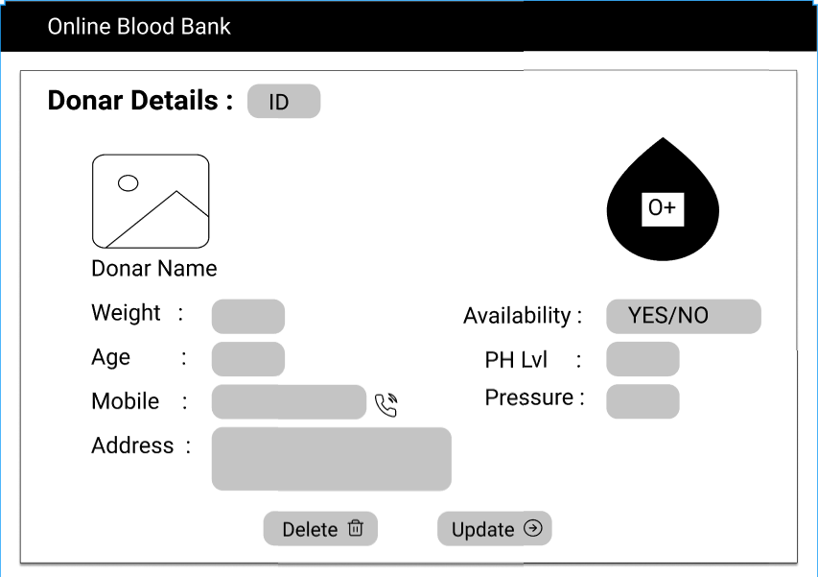

Backend:
Class and Method description:

Model Layer:

- UserModel: This class stores the user type (admin or the User) and all user information.
  - Attributes:
    - email: String
    - password: String
    - mobileNumber: String
    - active: Boolean
    - role: String
  - Methods: -
- LoginModel: This class contains the email and password of the user.
  - Attributes:
    - email: String
    - password: String
  - Methods: -
- BloodDonarModel: This class stores the details of the Blood Donor.
  - Attributes:
    - Id: String
    - donarName: UserModel
    - bloodGroup: String
    - PHLevel: String
    - bloodPressure: String
    - active: Boolean
  - Methods: -
- BloodBankModel: This class stores the Blood Bank details.
  - Attributes:
    - bloodBankID: String
    - bloodGroup: String
    - bloodPressure: String
    - PHLevel: String
    - Quantity: int
  - Methods: -
Controller Layer:
- SignupController: This class control the user signup
  - Attributes: -
  - Methods:
    - saveUser(UserModel user): This method helps to store users in the database and return true or false based on the database transaction.
- LoginController: This class controls the user login.
  - Attributes: -
  - Methods:
    - checkUser(LoginModel data): This method helps the user to sign up for the application and must return true or false
- DonorController: This class controls the add/edit/update/view products.
  - Attributes: -
  - Methods:
    - List<DonorModel> getDonor(): This method helps the users to fetch all Donors from the database.
    - DonorModel getDonorByID(String id): This method helps to retrieve a donor from the database based on the user id.
    - DonorModel getDonorByBloodGroup(String group): This method helps to retrieve a donor from the database based on the blood group.
    - updateDonar(DonorModel data): This method helps to update a donor and save it to the database.
    - addDonar(DonorModel data): This method helps to add a new donor to the database.
    - removeDonor (String id): This method helps to delete a donor from the database.
- BloodBankController: This class helps in adding blood sample to the database, deleting the blood sample from the database, updating sample in the database.
  - Attributes: -
  - Methods:
    - addBlood(String id): This method helps the admin to add the blood sample to the database.
    - List<BloodBankModel> showBloodSample(): This method helps to view all blood sample.
    - removeBloodSample (String id): This method helps to delete a blood sample by Id.
    - updateBloodSample (BloodBank data): This method helps to update a blood sample details.

